# Loading the student challenge amplifier control software into a custom FPGA myRIO Labview project

Step 1: Open a new custom FPGA project in Labview.

The following project explorer should appear.

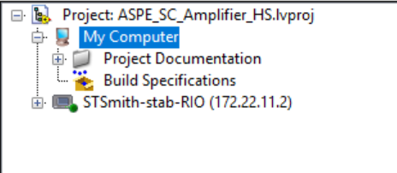

Step 2: Expand chassis and FPGA folders

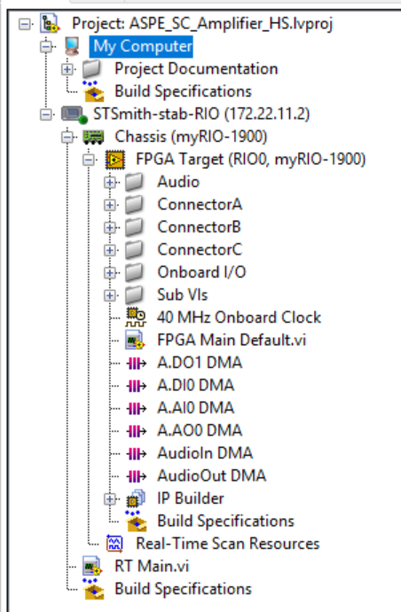

Step 3: Load the four Labview vi’s into the folders.

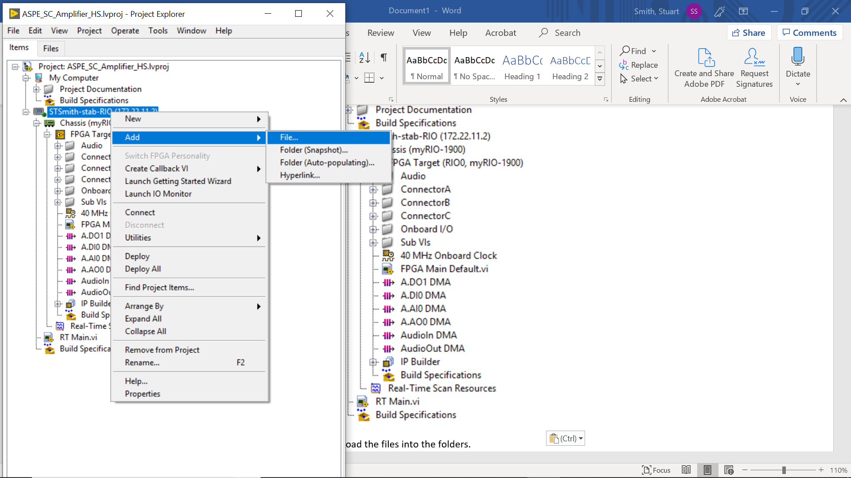

After adding the files the project should look like

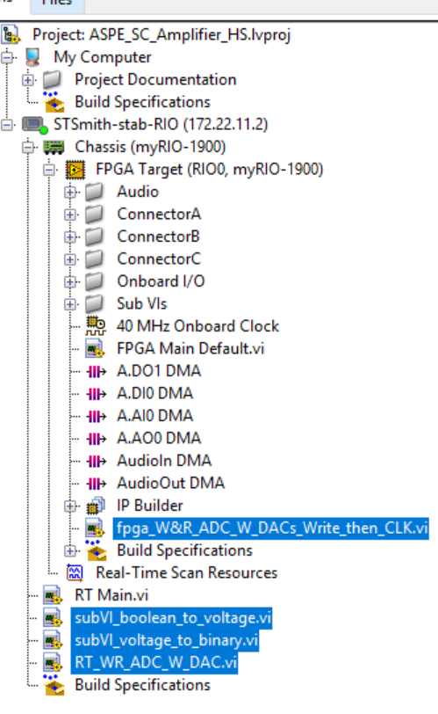

Step 4: Compile the fpga vi and then the RT program.